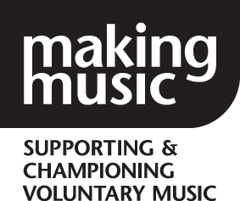
Making Music
The National Federation of Music Societies
8 Holyrood Street
London SE1 2EL

Tel 020 7939 6030
info@makingmusic.org.uk
www.makingmusic.org.uk

The Duchess of Kent Patron

Making Music Board of Directors: Nomination Form 2017

I, . . . . . . . . . . . . . . . . . . . . . . . . . . . . . . . . . . . . . . . . . . . (print full name)

Of

. . . . . . . . . . . . . . . . . . . . . . . . . . . . . . . . . . . . . . . . . . . . . (name of full member group)

Hereby declare that I wish to stand for election to the Making Music Board of Directors and undertake to serve if elected.

. . . . . . . . . . . . . . . . . . . . . . . . . . . . . . (signature) . . . . . . . . . . . . . . . . (date)

Supported by (member of same full member group):

. . . . . . . . . . . . . . . . . . . . . . . . . . . . . . . . . . . . . . . . . . . . . (print full name)

. . . . . . . . . . . . . . . . . . . . . . . . . . . . . . (signature) . . . . . . . . . . . . . . . . (date)

Supported by (member of same full member group):

. . . . . . . . . . . . . . . . . . . . . . . . . . . . . . . . . . . . . . . . . . . . . (print full name)

. . . . . . . . . . . . . . . . . . . . . . . . . . . . . . (signature) . . . . . . . . . . . . . . . . (date)

Why should members vote for you? Please write a maximum of 200 words. This will be published with the voting papers which will go to all members eligible to vote.

Please email completed form to info@makingmusic.org.uk by Monday 22 May 2017.

