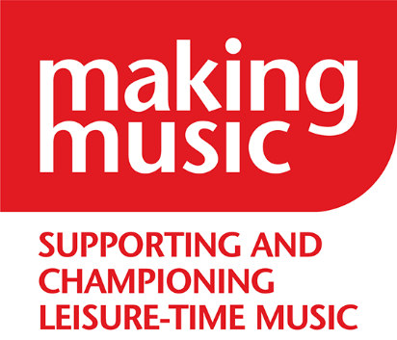
Making Music
The National Federation of Music Societies
8 Holyrood Street
London SE1 2EL

Tel 020 7939 6030
info@makingmusic.org.uk
www.makingmusic.org.uk

The Duchess of Kent Patron
Debbie Wiseman OBE President

Dear Applicant,

Finance & Office Administrator

Thank you for your interest in this job with Making Music.

We are looking for the best person for this role, whatever your past opportunities, so we are asking you to complete three tasks online, and your answers to these will be the only information the two staff members making a longlist will look at.

We understand that having different voices from all sections of society in our team will help us be the best organisation we can be and best support our diverse membership. We especially welcome applications from disabled people, from people of the Global Majority or from people whose socio-economic background has limited their opportunities.

We are committed to making adjustments to our application process – please get in touch and tell us what we can do: we want you to have the best chance at showing us what you are capable of. Please email Harriet (vacancies@makingmusic.org.uk) or phone 020 7939 6030 and ask for Harriet.

Together with this letter, we hope you have downloaded the job description which tells you what we will expect you to do in this job and what we are looking for from you.

If you would like to apply, please complete the application form on our website. We ask you:
- for your contact details, so we can get in touch if we would like to meet you for an interview, but these will be separated from the rest of your application
- to complete three tasks/questions and it is your answers to these ONLY which the two members of our team will be using to make a longlist of candidates

If you are on the longlist, we will then ask you:
- to complete a second form with your education and employment or volunteer experience
- to answer one more question: whether you have experienced barriers to opportunity in the past due to a protected characteristic (age, gender reassignment, disability, race including colour, nationality, ethnic or national origin, religion or belief, sex, sexual orientation) or your socio-economic background. If you have, and we have to decide between candidates of equal merit for interview, we will take positive action to include you on the interview list.

Timeline

- Please complete the application form no later than 9am on Monday 12 February 2024

- We will contact you by 5pm on Thursday 15 February if you are longlisted and we would like you to submit the second stage of information

- Deadline for submission of second form – 9am on Monday 19 February

- We will notify you by 5pm on Monday 19 February if we would like to interview you

- Wednesday 21 February - Interviews will be in person in our office in London (near London Bridge). If invited for interview, we will ask you about adjustments and about whether the time of the interview is important for you. We will pay your travel expenses to come to interview.

For more information about Making Music, see www.makingmusic.org.uk. If you would like more information about the job, please email Harriet (vacancies@makingmusic.org.uk) or call us on 020 7939 6030.

We look forward to receiving your application.

Yours faithfully,

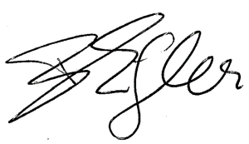

Barbara Eifler, Chief Executive

