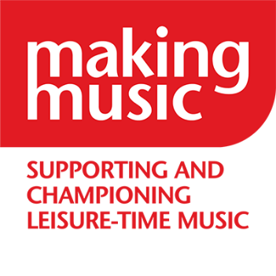
Making Music
The National Federation of Music Societies
8 Holyrood Street
London SE1 2EL
Tel 020 79396030
info@makingmusic.org.uk
www.makingmusic.org.uk

Debbie Wiseman OBE President
The Duchess of Kent Patron

Voting Paper

You are only allowed to vote if you are the Making Music Representative of a Full Member of Making Music, the National Federation of Music Societies.

Your name:……………………………………………………………………………………..

Your full member group:…………………………………………………………………….

Please return your completed voting paper to us by 9am on 11 July 2023. You can:

- Fill in your name and group, and tick the box(es) electronically, save the document and email it to us at elections@makingmusic.org.uk
- Print out this paper, fill in your name and group, place a cross in the appropriate box(es), scan it in and email it to us at elections@makingmusic.org.uk
- Print out this paper, fill in your name and group, place a cross in the appropriate box(es) and post it to us: Making Music Elections, 8 Holyrood Street, London SE1 2EL.

Please vote for up to three (3) candidates out of the eleven (11) standing for election.

It is also possible to vote for candidates online at: https://www.makingmusic.org.uk/making-music-board-election-voting. The AGM will announce the result of the election and appoint the three candidates with the highest number of votes.

Candidates are listed (on the next page) in alphabetical order (surname).

Please see the separate document with the candidates’ statement for more information on each candidate and to help you select who you would like to vote for.

Candidate number | Candidate name | Tick to vote
1 | Stephen Bashforth
2 | Joyce Chamberlain
3 | Andrew Devine
4 | Peter Fanning
5 | Rhiannon Harrison
6 | Olivia Jollands
7 | Stephen Locke
8 | Kathy McLeish
9 | Caroline Mozley
10 | Dafydd Roberts
11 | Catherine Travers

