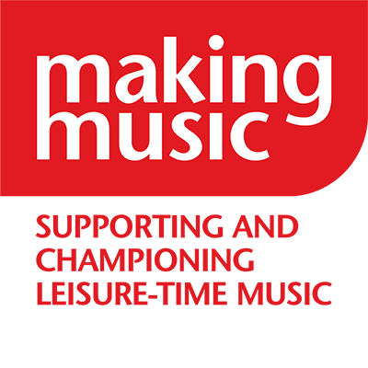
Making Music
Member Communications & Engagement Manager

Application task brief

Contents
Use of AI for your task responses 1
Task 1 – email campaign planning 2
Task 2 – member engagement campaign message 2
Task 3 – using AI to optimise a member email 2

Use of AI for your task responses
We value authenticity and transparency. Task three below requires the use of AI tools. The other tasks (tasks one and two) do not. If you want your application to stand out, using a generic AI-generated response for tasks one and two isn’t going to separate you from the crowd, even if it promises to personalise the response.
If you do use AI for tasks one and two, it should enhance your written application and showcase your best self. It’s not about creating a persona that isn’t you.
Whilst we do not prohibit the use of AI for tasks one and two, we caution the following:
- AI-generated content may lack specificity and fail to address key criteria outlined in the job description.
- Personalisation is essential to convey individual skills, knowledge, and experiences effectively.
- Over reliance on AI-generated content is discouraged and may diminish the applicant’s chances of success.
- Where AI has been used, we ask applicants to declare this in their applications in the interests of transparency.

Task 1 – email campaign planning
Making Music is launching a new onboarding journey for newly joined member groups. You’ve been asked to plan the first three emails in this journey.

Please outline the content and purpose of the first three emails in the onboarding series. For each email, include:
- A subject line
- A short summary of the email’s content and purpose (up to 100 words for each email)
- The intended outcome or call to action

This should take up to 45 minutes to complete.

Task 2 – member engagement campaign message
You’re planning a campaign to encourage members to share their group’s recent achievements, stories, or photos for use in Making Music’s communications (e.g. newsletters, website, social media).

Write a short message (max 150 words) that could be used in a member email to:
- Encourage members to share their stories or photos
- Explain why their contributions matter
- Reflect Making Music’s tone: warm, inclusive, and community-focused

This should take 15-25 minutes to complete

Task 3 – using AI to optimise a member email
You’ve drafted a short email to promote an upcoming member webinar. You want to improve the subject line and preview text to increase open rates.

Use an AI tool of your choice (e.g. ChatGPT, Grammarly, Notion AI, etc.) to:
- Suggest 2–3 improved subject lines
- Suggest 2-3 body text improvements
- Briefly explain what prompt(s) you used, which options you chose and why

You may use your own AI account or a free tool. Please copy and paste your results and explanation.

This should take up to 15 minutes to complete.

Here’s the email:

Subject: Jun-Jul events round up – dates for your diary!

Dear [Member_Name],
Don’t miss out on our upcoming events! Click on the links below to find out more and reserve your place.

Making a difference – how to campaign on a local issue
Fri 25 July, 10 am
When your group's venue, funding, or vital service is under threat, how can you effectively campaign to protect it? In this event, we’ll be talking to some of the members we’ve helped to successfully campaign on local issues, from saving music libraries to securing vital support. We will also be introducing a new resource to support members building a campaign.

Open meeting for leisure-time instrumental ensemble conductors
Mon 28 July, 4 pm
Following the success of the first one, Making Music will be hosting this session to facilitate musical directors of instrumental leisure time music groups discussing development and opportunities. Topics will include the relationship between MD and committee, diversifying repertoire, and more!

Events from our Friends
Association of British Choral Directors – London Conducting Weekend Sat 25 Oct – Sun 26 Oct
Natural Voice Network – find a range of upcoming events run by Natural Voice Network members here.

Visit our events page for all our upcoming events!
Best wishes,
Harriet Laidler
Projects & Events Manager

