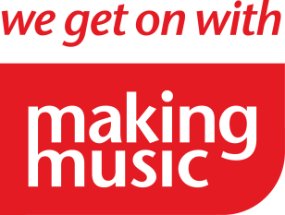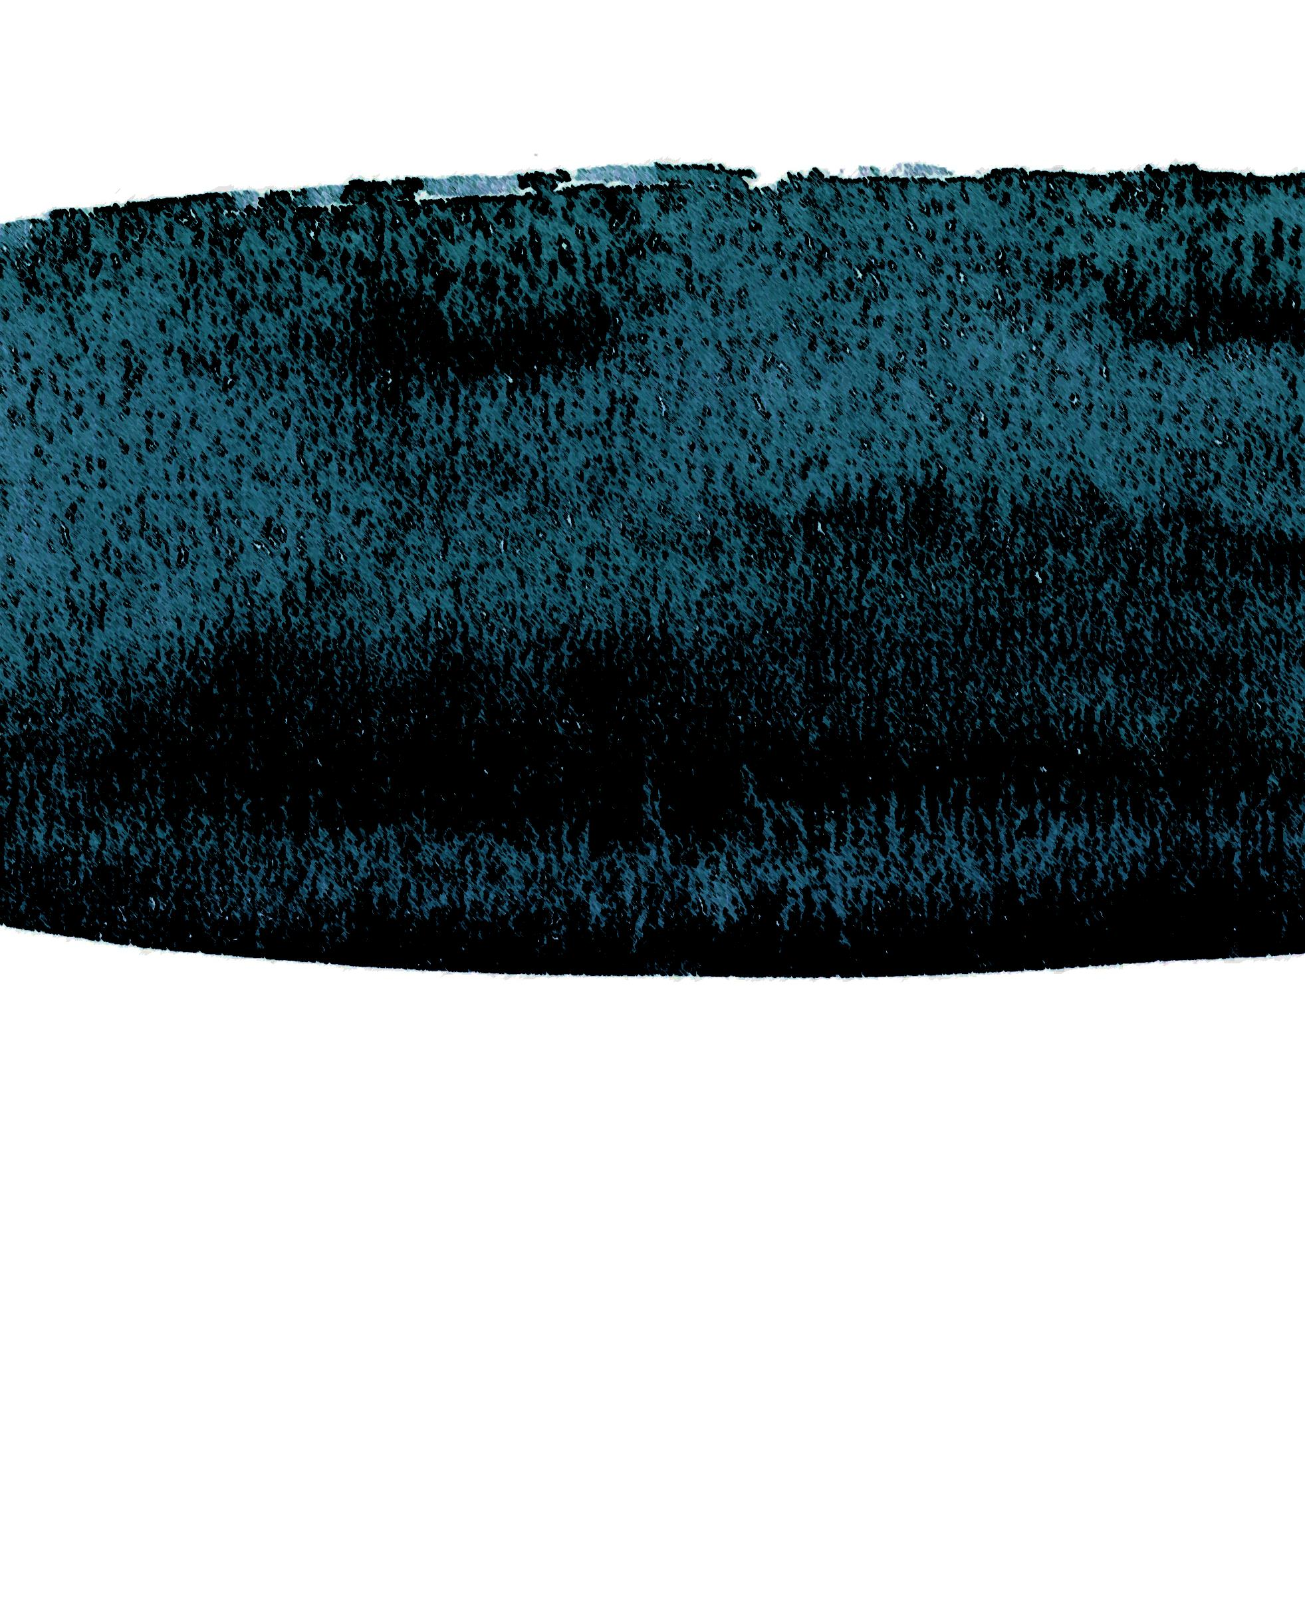

**BEETHOVEN – NELSEN – GRIEG**

**TICKETS: £5 (£3)   
ON THE DOOR OR 0782 993 8475   
  
  
WWW.OCMS-MUSIC.ORG.UK**

**OLSANG & FARHAM MUSIC SOCIETY PRESENTS**

**Olsang Hall, NE14 NF8**

**17 October 2016, 8pm**

NIGHTINGALE **STRING   
QUARTET**

**QUARTETS**