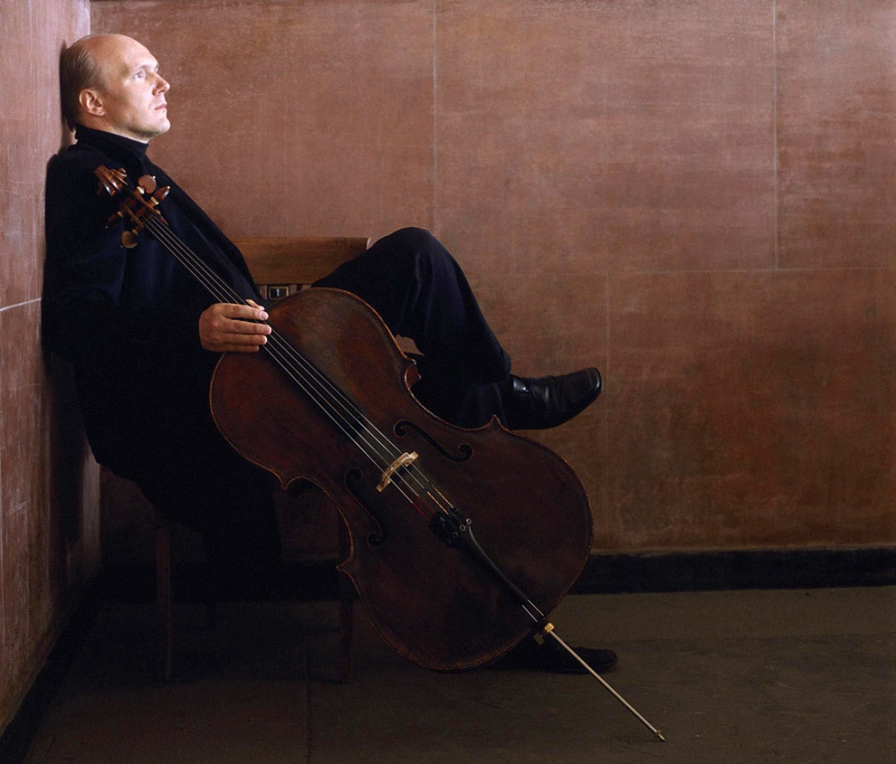

**Kodály |** Sonata for Solo Cello

**Bach |** Suite No. 1 in G

**Britten |** Third Suite for Cello

**TICKETS: £8 - ON THE DOOR, OR 07918 262 475**

**CHANDHOUSE HALL, BOBSHIRE, MN3 2PG**

**www.chandhouseorchestra.com**

**CHANDHOUSE CONCERT SOCIETY**

**FRIDAY 6 FEB 6.30PM**

**PHIL**

**BARBER**