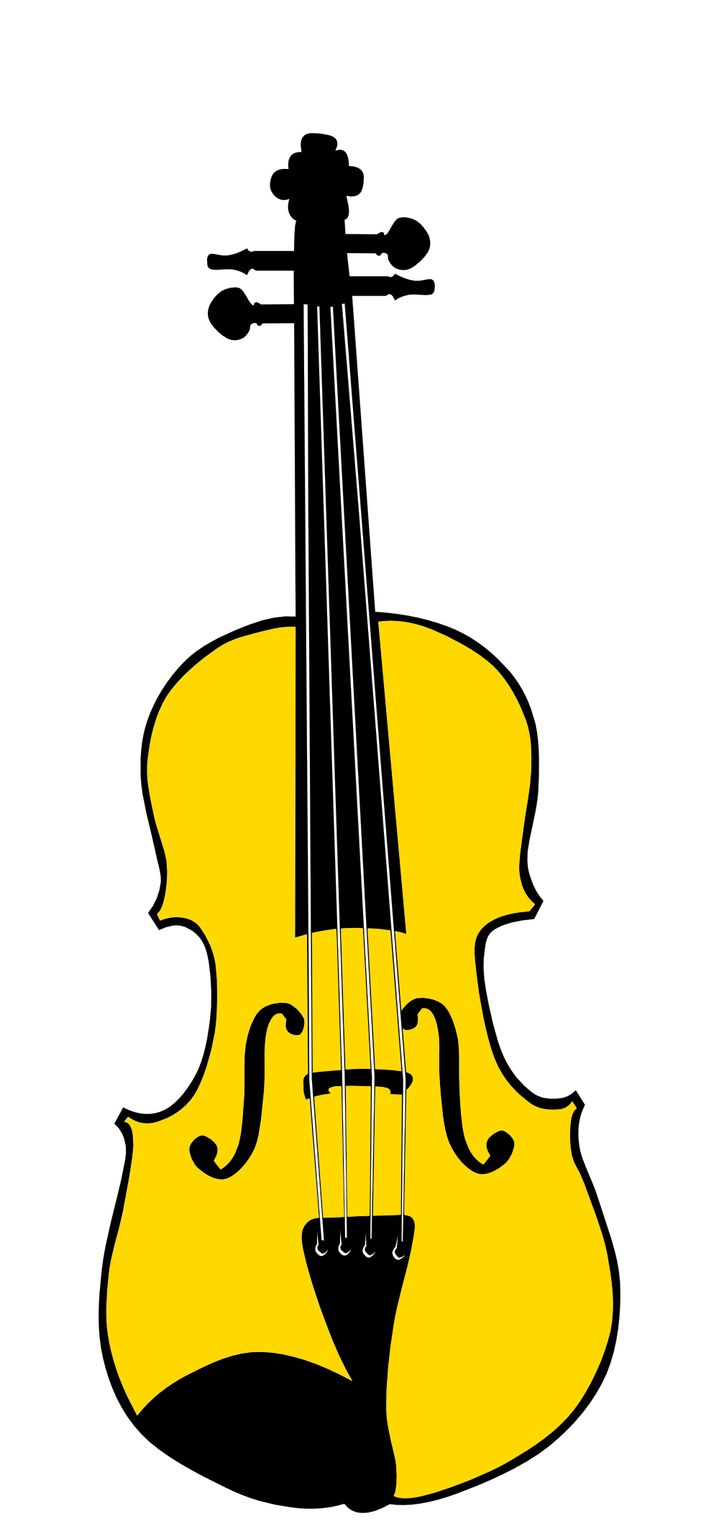

www.olshottchoral.org.uk

**OLSHOTT CHORAL SOCIETY**

TICKETS: £6 (£4 for under-16s)  
BOOKING: 0788 364 5868

22 DECEMBER | 6PM

BOMHAM HALL, OLSHOT, PR23 2ET.

Christmas Concert