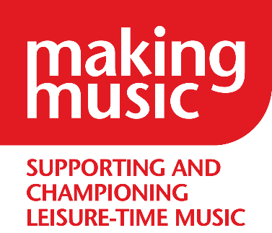
Music Group information for Link Workers

This is a template – please feel free to save and edit before sending to your link worker(s).
They may also require additional information to that considered in this document.

QUESTIONS | NOTES
Your group’s name, a contact name, email address & telephone number
When and where does the group meet?
What kind of music does the group sing or play?
If an instrumental group, do you have instruments to lend to participants?
Is there a need to be able to read music, or can the music be learned aurally?
Is the group auditioned, or is there a particular level of skill required?

Are there limitations on the type of person that can join? E.g. age, gender, sexuality, ethnicity
Does the group have appropriate safeguarding in place, e.g.
· Insurance
· safeguarding policy incl. working with vulnerable adults
· first aid (including mental health first aid)
· data protection
· DBS checks
· risk assessment

QUESTIONS | NOTES
Are there taster opportunities before committing?
Is there a cost to singing or playing with the group?
What experience, if any, does the group have of accommodating a range of conditions?
Do the leadership and members of the group feel comfortable accommodating a range of conditions?

How will the group ensure that the patient feels welcome? Will there be a buddy, for example? Do you have a ‘group profile’ for the patient to learn about the group before arriving?
How many referrals could the group accommodate?

