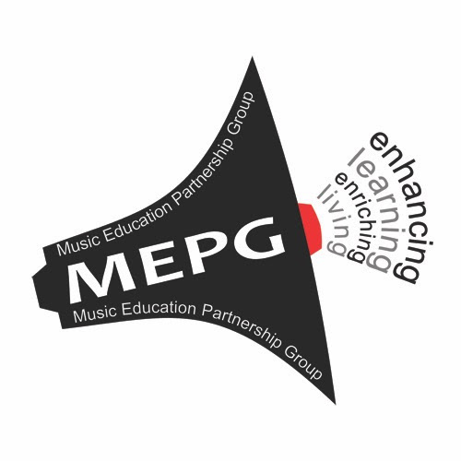

MUSIC EDUCATION PARTNERSHIP GROUP
enriching living and enhancing learning through music education

STRATEGY 2022-26

To realise music’s potential to transform life chances

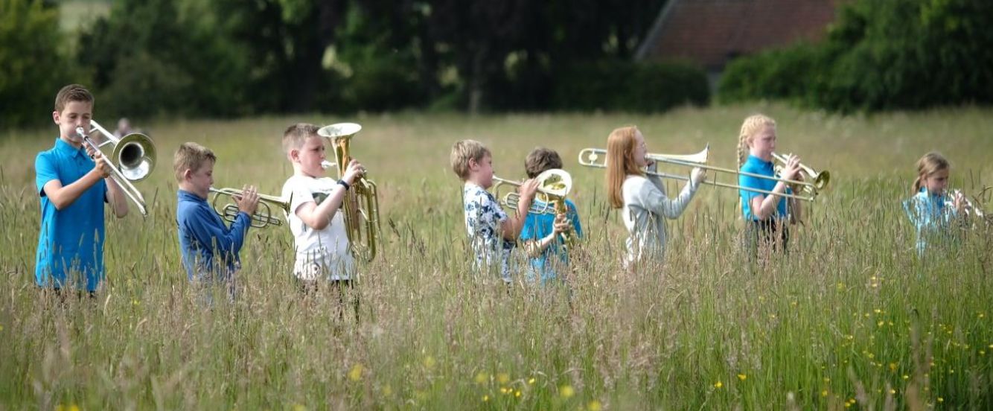

CONTENTS

Strategy
The Music Education Partnership Group 3
A Note on Terms 4
Vision, Mission and Aims 6
MEPG Strategy 2022-2026 7
Aim 1 10
Aim 2 12
Aim 3 14

Annex to Strategy
We Make Music 16
We Make Music as part of strategy delivery 16
We Make Music - Three Strands 18
We Make Music Pathways 18
We Make Music Schools 19
We Make Music Digital 19
MEPG Membership 21

Pictures:
Front page: StAMP (St Andrews Music Participation) children playing at Kellie Castle, Fife, June 2021, in the East Neuk Festival
Page 5: MEPG Play to Learn Day, June 2019, with Sir James Macmillan conducting the West of Scotland Schools Symphony Orchestra, augmented by schoolchildren from all over Scotland, including the Highlands and Islands
Page 9: RCS Junior Conservatoire percussion students, April 2021
Page 21: National Youth Choir of Scotland

Everyone has the right to participate freely in musical life
(Article 27, Universal Declaration of Human Rights)

The Music Education Partnership Group

The Music Education Partnership Group (MEPG) founded in 2015, is a network of music-based organisations with a Scottish focus. It was set up to promote and celebrate the life-long benefits of a music education and to advocate that the transformative potential of music should be experienced by everyone in Scotland. This MEPG strategy also reflects developing practice in music education across the United Kingdom and internationally.

MEPG, as an independent charity, brings together the diverse music teaching constituencies, formal, nonformal, informal, in the public and third sectors. It aims to optimise the music education capacity of Scotland and to extend the benefits of making music to as many of Scotland’s people as want to learn.
An overwhelming body of evidence suggests that, not only is the pursuit of music enriching in itself, but also that its practice has a profound effect on personal development and to mental and physical health and wellbeing. From the earliest years onwards, the practice of music develops creativity and communication, resulting in transferable skills such as team working, resilience, discipline, performing, problem solving, evaluating, abstract thinking, physical and fine motor coordination.

This refreshed MEPG Strategy sits within the context of the United Nations Convention on the Rights of the Child. The UNCRC is the global gold standard for children’s rights and sets out the fundamental rights of all children. The UNCRC, the most widely ratified human rights treaty in the world, sets out the specific rights that all children have to help fulfil their potential, including rights relating to health and education, leisure and play, fair and equal treatment, protection from exploitation and the right to be heard.

A Note on Terms

Music Education

- Exploring creativity in music
- Enabling children and adults to express themselves creatively through singing, vocalising, signing, and playing a musical instrument
- Enabling a range of skills including improvisation, composition, playing by ear, reading music, ensemble playing
- Using movement and body percussion in creative musical activity
- Using software to create and perform music
- Enabling skills in recording, editing, mixing, producing, and syncing recorded music
- Staging diverse musical events in diverse locations with diverse goals

Music in Education

The use of musical activities in delivering education activities where the primary goal is delivering outcomes from other areas of the curriculum, while at the same time delivering musical and creative outcomes.

The term ‘Music Education’ in this document should be taken to include both approaches

Formal, Non-Formal, Informal

Formal: the structured, chronologically graded system (state and privately funded), running from early years, through primary school and into higher education

Non-formal: any organised educational activity outside the established formal system that is intended to serve identifiable learning clienteles and learning objectives

Informal: the lifelong process whereby every individual acquires attitudes, skills, and knowledge from daily experiences and the educative influences and resources in their environment (family and neighbours, work and play, the marketplace, the internet, the library, and the mass media).

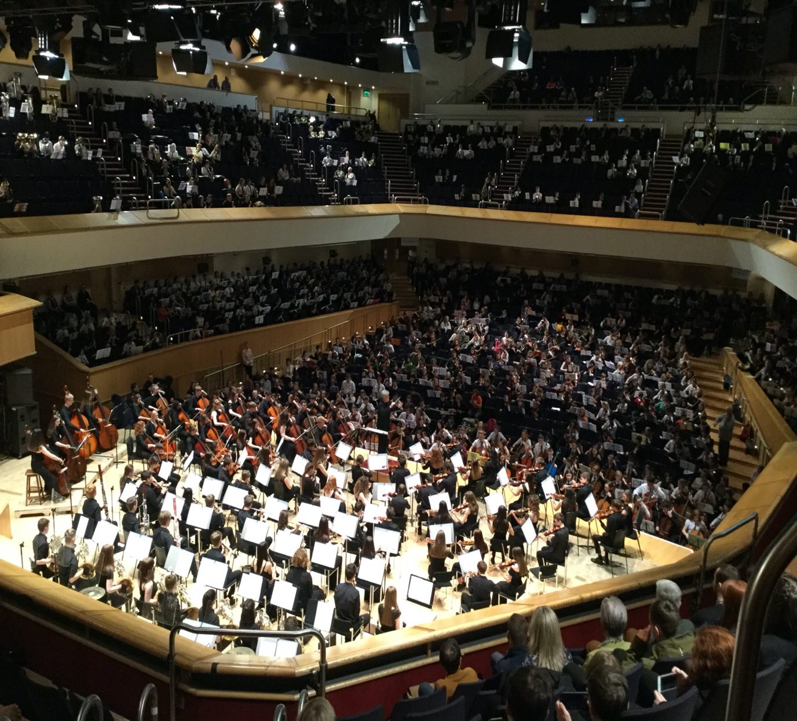

Our Vision
Scotland as a place where the transformative potential of music is valued, nurtured, and experienced by all

Our Mission

To realise music’s potential to transform life chances

Our Aims

To promote equity of access to music provision

To foster quality learning experiences

To improve perceptions of the value of music
education

We celebrate the diversity and excellence of music in Scotland and the value of open exchange with the wider world
A Culture Strategy for Scotland

MEPG STRATEGY 2022-26

To realise music's potential to transform life chances

This 2022 strategic plan is a refresh of MEPG’s 2020-25 strategy TACKLE inequity REALISE potential CHANGE perceptions. Many of the long-term aims are unaltered. The pandemic, COVID-19 recovery, and consequent uncertainties, however, have necessitated a refocus of priorities. It is striking how much was achieved in the first eighteen months of this MEPG strategy. One of the plan’s long-term aims: to ‘work with government national and local long term to remove tuition fees’ was achieved much more quickly than anticipated. This alone was enough to prompt a refreshed strategy seeking to embed many of the positive gains which grew out of the successful campaign which the MEPG partners ran with the main political parties into the May 2021 elections for the Scottish Parliament.

The vision and mission have been refocused. Ambitions remain high. The strategy reflects the MEPG partnership’s growing cohort of community-based organisations. Giving every child in Scotland access to a quality Music Education is still an essential driver. But it is taken as read that achievement of our refocused vision, positioning ‘Scotland as a place where the transformative potential of music is valued, nurtured, and experienced by everyone’, would establish Scotland as a world leader in music education as in the previous vision.
The place of music and music education within the school curriculum and the wider society in Scotland is an important and live issue. We recognise the work, carried out in Scotland by Malloch and Trevarthen on Communicative Musicality, the two-way musical and creative communication of vocal sounds that occurs instinctively and universally across all cultures between babies and parents. The new born brain is hard-wired not only to be musical and creative but also to detect creativity in the responses of another. This places musicality and creativity at the centre of what it is to be human.
As a scientific, educational, and artistic community we are just beginning to understand the role music and creativity plays in fostering learning and development in the brain from before birth, crucially through Early Years and Primary ages of a child’s life, and then on to life-long learning. We wish, therefore, to understand and foster activity that can impact children’s development in these two key overlapping areas. Musicality and creativity have a key role in closing the attainment gap, helping all children fulfil their potential, with impact on health, well-being, and economic outcomes. They can improve outcomes in listening and communication skills, literacy, numeracy, and improve children’s general relationship with learning and education. Finally, a focus on musicality and creativity will prepare a more diverse and inclusive cohort of Scottish children to enter the varied streams of music education available, whether for vocal or instrumental study in performance in a wide range of genres, in composition, improvisation, production, engineering, and research. It will also provide a grounding in the creative collaboration, expression and leadership skills that provide a basis for artistic practice and careers right across the expressive arts.
The pandemic has disproportionately affected the delivery of music in schools. We know it has also disproportionately affected those already disadvantaged by inequalities in our society and has had a serious impact on our children’s education. But, as we evolve from COVID-19 emergency to recovery, music, both inside and outside school, will take on increasing significance as a source of social cohesion, and as a means of developing and supporting our children’s creativity, mental and physical health, their well-being, and their ability to socialise. These arguments for music education as an essential element of COVID-19 recovery are well-evidenced and compelling.

Article 31 of the UN Convention on the Rights of the Child has been incorporated into every aspect of Scottish governmental policies. Music education is a major component of one of those policies, A Culture Strategy for Scotland. Rightly so, as music across all genres remains intensely popular amongst people of all ages. In the light of the Government’s commitment to the UN Convention we aim to ensure that all children continue to have the opportunity to participate in music and that young people’s voices are heard and involved in planning and decision-making as of right.

The catalyst for our 2020 strategic plan was the What’s Going on Now? research, which identified that many more children and young people from disadvantaged backgrounds would participate in instrumental music tuition given the opportunity. This MEPG strategic plan seeks to develop the existing productive relationships within the membership of the Music Education Partnership Group to deliver an exceptional result for Scotland in meeting this demand across all genres and across Scotland’s diverse communities. The strategic approaches in this strategy will be brought together under the framework of a new initiative, We Make Music, a fresh approach arising from the What’s Going on Now? research recommendations.
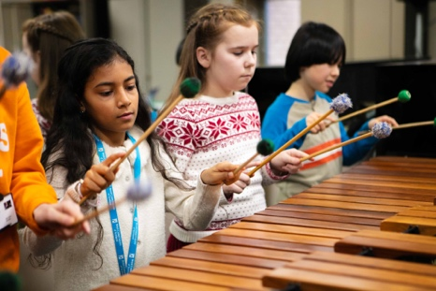
We develop the conditions and skills for music to thrive, so that it is cared for, valued, and protected for the enrichment of all children and young people in Scotland
A Culture Strategy for Scotland

AIM ONE
To promote equity of access to music provision

In order to realise music’s potential to transform life chances and personal achievement we have to recognise that life chances for children in Scotland are still inequitably distributed, depending on where they live, family circumstances, income, ethnicity, disability, and a range of other factors.

In order to rebalance that inequitable distribution, therefore, promoting equity of access to music provision is a key strategic aim. MEPG seeks to achieve a fair and equal situation across Scotland in which the many benefits of music education are accessible to all who want it. The system of tuition fees which constituted the major barrier to equality of opportunity in the formal sector has been abolished, but there remain a number of other barriers. The complex interplay of factors that create these barriers is still not clearly understood, so MEPG is committed to clarifying that understanding.

We propose three key programmes of work under this aim:
- the gathering of data, information, and research evidence on the wider benefits of music in education at all stages of development
- the transition to free tuition
- support for teachers in the formal sector and for teaching musicians in the non-formal and informal sector
These areas will require important input and analysis from the continued work of sub-groups within the MEPG partnership, extending the work of the Youth Forum, the development of research proposals, co-operation with Scottish Government and COSLA, and, longer-term, the development of the national We Make Music framework to support teachers and teaching musicians (more information on We Make Music can be found in the Annex).
Short-term tasks 22/23

- Begin longitudinal research to understand and explain the multiple barriers to participation where inequity persists in relation to music education
- Produce a rich and comprehensive infographic map of the present music education ecosystem
- Contribute to the Scottish Government and COSLA working party set up to construct policy aligned to the introduction of universal free instrumental music tuition
- Build the Youth Forum and integrate into the work of the partnership
- Complete and publish research into teacher confidence in teaching music in primary schools

Medium-term goals 23/24

- Complete and publish longitudinal research on barriers to equity
- Continue work with SG and COSLA on equity of access to music education

Longer-term objectives 25/26

- Implement, in tandem with Aim Two, a national We Make Music framework in support of instructors, and classroom teachers delivering music education through Curriculum for Excellence, and inclusive of those working in the non-formal and informal community sector.

Maximise all opportunities for children to enjoy the rights to rest, leisure, recreation, and cultural and artistic activities and address structural inequalities that constrain these rights.
UN Convention on the Rights of the Child

AIM TWO
To foster quality learning experiences

This aim interlocks with aims one and three. Through working in closer partnership between providers, local authorities, schools, and agencies such as Creative Scotland, MEPG will seek to build on the opportunity of free tuition to ensure equity of access to a quality experience of music education and music in education for more people. To realise the potential of children and young people involved in music in Scotland’s schools, the MEPG partnership, in close consultation with the music education constituency, will design the programme recommended by the What’s Going on Now? research - We Make Music - to build on and run in parallel with the Youth Music Initiative (YMI). This will ensure that every child and young person will have the chance to benefit from a sustained quality music education with pathways to personal achievement including employment.

We propose four key areas of work under this aim:
- We Make Music school pilots
- We Make Music instrument libraries
- Working Parties on Pedagogy and Teacher Education; Blended Learning; Creativity
- The We Make Music framework

(for further information about We Make Music, please see the Annex)

Short-term tasks 22/23

- Set up and run the first We Make Music (WMM) school pilots in Renfrewshire and Perth and Kinross
- Co-ordinate with partners to set up and monitor the implementation of WMM instrument libraries in Edinburgh City, Fife, and North Ayrshire
- Set up and run appropriate working parties on the WMM programmes, on Pedagogy and Teacher Education, Blended Learning and Creativity
- Informed by the working parties, construct a WMM Framework which straddles the formal, informal, and non-formal sectors

Medium-term goals 23/24

- On the experience of the first WMM school pilots extend more widely to other areas interested in take up
- On the experience of the first WMM instrument libraries in Edinburgh City, Fife, and North Ayrshire, extend more widely to other local authority areas
- Explore a co-ordinated maintenance and repair system for a system of WMM instrument libraries

Longer-term objectives 25/26

- Extend the We Make Music programme nationally and harmonise with other expressive arts and education initiatives in the community aligned to the National Cultural Strategy
- Implement a national WMM instrument library system with maintenance, repair, and instrument exchange

Making Scotland the best place in the world to grow up where every child has the opportunity to learn and the means to express themselves through music
Time to Shine: Scotland’s Youth Arts Strategy

AIM THREE

To improve perceptions of the value of music education

This aim interlocks with aims one and two. Through improving perceptions of music education, MEPG seeks to bring greater public understanding of the value of a musical education for the individual and to wider society. The MEPG partnership will work to achieve raised appreciation of the value of music and those who teach it. Sustained advocacy will transform public and parental understanding of the life-long benefits of music-making, including how music helps and supports mental and physical health and wellbeing. This aspect of music’s benefits will also aid recovery from the Covid emergency. Members of the MEPG partnership will continue to work closely with the General Teaching Council for Scotland (GTCS) to gain registration for instrumental music instructors. Such status will enhance the perception of their value to children and young people’s education. This work will be complemented by CLPL opportunities for the music education workforce. MEPG will support public events which celebrate the joy of individual and collective music-making. MEPG will raise awareness of the positive career possibilities of music and the creative industries through careers events in partnership with the music industry sector.

Advocacy will focus on working with key bodies such as:
- Scottish Government, COSLA, Cross Party Group on Music, GTCS
And on exemplar programmes:
- Diversity of teaching staff; Career-long Professional Learning (CLPL)
- Scottish Young Musicians Festival; Sing to Learn and Play to Learn
Short-term tasks 22/23
- Participate in the Cross-Party Group for music and contribute towards cross-party support for music education in Parliament
- Contribute to intensive work with GTCS and other bodies towards designing registration for instrumental music instructors
- Advocate for a broadening of the diversity of teaching staff
- Cross cutting to the Pedagogy and Teacher Education and Creativity working parties in Aim 2, encourage partners to design CLPL to broaden and diversify the teacher workforce
- Set up a Scottish Young Musicians festival celebrating the personal achievement of young music makers across every local authority in Scotland
- Hold a MEPG Sing & Play to Learn national event at the GRCH
- Establish a dialogue with the proposed National Centre for Music

Medium-term Goals 23/24
- Working together with GTCS and other bodies gain registration for teachers through an Act of Parliament
- Offer a raft of CLPL qualifications in place to enhance life-long teacher education and to broaden the diversity, skill-base and capacities of the workforce
- Extend the genres and categories of the Scottish Young Musicians festival
- Hold a series of national and local MEPG Sing & Play to Learn events tied into the WMM programme timetable
- Work with partners to create music sector careers events across Scotland linked to Sing & Play to learn events

Longer-term Objectives 25/26
- To be able to celebrate a comprehensive Scottish Young Musicians Festival inclusive of Scotland’s diversity
- To have music at the core of a majority of Scotland’s schools
- To register, in public perception, Sing & Play to Learn as part of the national calendar
Annex

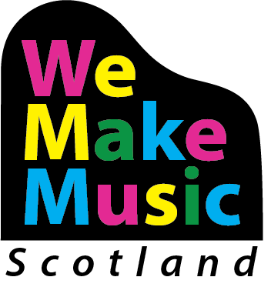

We Make Music
We Make Music is a fresh approach arising from the What’s Going on Now? research recommendations. As an evolving, participatory framework it will constitute one of the major delivery vehicles for the implementation of this strategy. We Make Music will develop an advisory and advocacy framework within which this strategy will be delivered. This will help ensure that Scotland is a place where music is valued, celebrated, and nurtured; where music is woven through everyday life, shaping, and being shaped by society, its transformative potential experienced by everyone. Music is the source of a rich musical heritage and creativity. It is inspired by people and place, enlivens every community, and is celebrated around the world.

Music is a popular subject in Scottish schools. Instrumental music tuition in schools is oversubscribed in many areas where demand outstrips supply. To assist supply in meeting unfulfilled demand for instrumental learning we will aim to support a more joined-up, coherent approach across the formal, non-formal and informal sectors to give better access to all who want to learn. Greater coherence in provision, essentially, is the We make Music approach.

We Make Music will be designed to build on the success of existing music education and run in parallel with the Youth Music Initiative which has become an important part of year-on-year delivery to children and young people.

- We Make Music (WMM) will be all genre, and Scotland-wide.
- Accreditation through a WMM kite-mark will be developed to celebrate good practice in music education in Scotland across the formal and non-formal sectors
- We Make Music will be supported by digital resources and a knowledge base accessible on tablets and mobile devices as part of a blended learning approach
- We will reach out to the MEPG Youth Forum, the National Parents Forum, and those children and young people involved in the Music Leaders programme to build the implementation of WMM
- WMM will build, develop, and support a stronger, more diverse and flexible workforce from different backgrounds with the skills to meet the needs of the wide range of learners enabling them to achieve their potential with pathways to further and higher learning
- Integral to WMM will be a mentoring system for tutors at all stages

We Make Music delivers the strategy:

Scotland as the best place to learn
The music education environment in Scotland is remarkable for its breadth and the current extent of collaboration between the classroom and vocal and instrumental teachers in every genre. There is scope in Scotland to deepen this culture of collaboration and to draw on the resources of Scotland’s indigenous and community languages. We Make Music will reach out to share experience with the other Expressive Arts (Dance, Drama, Art, and Design) to mutual benefit. Partnership-based delivery will aid music education to maximise its contribution towards the objective to make Scotland the best place to learn and educate through developing the attainment, physical and mental well-being of our children and young people.

Realising potential
We Make Music will facilitate community engagement and encourage life-long learning in addition to creating accessible pathways for all pupils including those with Additional Support Needs in primary, secondary, as well as special schools to tertiary education. The current pattern of uses and present formula for YMI awards will form the basis for greater integration of formal and non-formal learning opportunities inside and outside school. WMM pathways to individual achievement will lend additional prominence and coherence to the choices already out there.

Equity of access
The abolition of tuition fees gives a golden opportunity to develop exemplary 21st century music services. We Make Music funding will be allocated through an application/allocation process with Local Authorities and other providers similar to current YMI processes. Desired outcomes will include reduction of barriers to access and the creation of progression routes to individual achievement. The criteria of the funding will be flexible to allow local authorities to invest in the activities which would have the most significant impact in their area.

Coherence in provision
We Make Music will realise the potential of networks and partnerships to increase coherence in provision, ensuring quality and reach of delivery. We Make Music regards excellence and inclusion as complementary, and both of these two considerations will be paramount in the design of WMM delivery both before and after the introductory one-year tuition through YMI. Coherent provision of music teacher education and CLPL will allow the development and growth of our national skill-base of teachers allowing greater choices for all in self-fulfilment and possible future employment in the creative industries

We Make Music will have three strands: Pathways/Schools/Digital driving forward

- A culture of creativity in schools
- Access to opportunity for greater numbers of people
- A reduction in barriers to participation
- Staff development to extend good practice in pedagogy
- Diversity of genre
- Diversity of the workforce
- Improvements in physical and mental health and well-being
- Raising achievement and attainment in alignment with CfE delivery
- Improved school attendance
- Stronger music in the community

We Make Music Pathways

Central to music education in Scotland are the Instrumental Music Services delivered by local authorities. In addition, this spine of music provision is complemented and reinforced by a dynamic, flexible, and innovative complex of organisations and freelancers delivering specific programmes and projects to local authorities and individual schools. We Make Music Pathways will facilitate an active network of all those parties involved in creating individual routes to achievement through diverse approaches to music education in all genres and styles of music across Scotland’s diverse communities. National companies and local community groups, and members of the wider network of providers will liaise with Local Authorities, Head Teachers, and schools to develop pathways within and outwith school, and through tertiary education, including partnerships and collaboration with the music industry. Teaching and teacher education pathways for young disabled music learners and teachers will be established.

We Make Music Schools

Schools will become a We Make Music School in a similar way to Eco Schools or Reading Schools. MEPG will develop criteria for schools to achieve the award. Awards will be given in a number of ways – through participation, excellence, and community engagement. Different levels – Gold, Silver, Bronze, will allow for progression as schools develop their programmes. This will work in conjunction with the Pathways programme. We Make Music Schools will be an important point in the journey to realise the potential achievement of Scotland’s children and young people.

We Make Music Digital

We Make Music Digital will aim to build on the existing expertise of MEPG partners. It will encompass composition on digital platforms, recording, editing, production, and online collaboration. Digital platforms will be used and developed to enhance the face-to-face work in music education on the ground, and to overcome geographic barriers to participation. Exciting opportunities for Digital enhancement lie in the following areas:
- Resources
- Register of teachers
- Teacher support
- online teaching
- pupil support
- opportunities to participate in music in the community
- concerts/events diaries
- careers advice
Music is the best way of building a creative, sociable, fun, and engaging atmosphere online, and We Make Music Digital will explore the connections between online, in-person and blended learning environments.
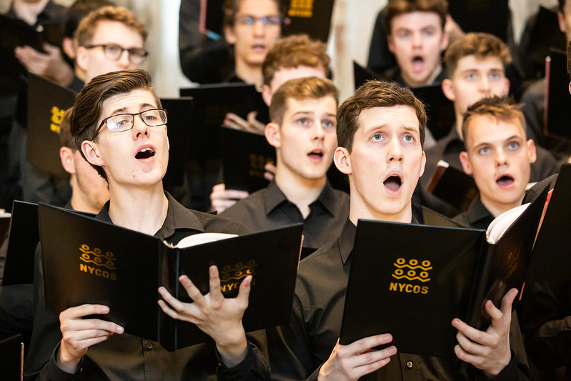
THE MEPG MEMBERSHIP

ABC Creative Music  Academy of Music and Sound  Agar Trust  Associated Board of the Royal Schools of Music (ABRSM)  Association of British Orchestras (ABO)  Association of Directors of Education in Scotland (ADES)  BBC Scottish Symphony Orchestra (SSO)  Beat Buddies Music  Benedetti Foundation  Children’s Classics Concerts (CCC)  City of Edinburgh Council  Creative Scotland (CS)  Cumnock Tryst  Drake Music Scotland  Dumfries and Galloway Council  Edinburgh College  City of Edinburgh Music School  Education Scotland (ES)  Education Institute of Scotland (EIS)  Enterprise Music Scotland (EMS)  Fèisean nan Gàidheal  Fischy Music  Glasgow Barons  Heads of Instrumental Teaching Scotland (HITS)  High Life Highland  Incorporated Society of Musicians (ISM)  Live Music Now Scotland (LMNS)  Making Music  MPA Group  Music Education Council (MEC)  Music School of Douglas Academy | Music Mark  Music Publishers Association (MPA)  Musicians Union (MU)  National Centre for Excellence in Traditional Music, Plockton  National Centre for Music  National Parent Forum Scotland  National Piping Centre  National Youth Choir of Scotland (NYCOS)  National Youth Orchestra of Scotland (NYOS)  National Youth Pipe Band of Scotland (NYPBoS)  Nevis Ensemble  Oi Musica  Red Note Ensemble  Royal Conservatoire of Scotland (RCS)  Royal Scottish National Orchestra (RSNO)  Scottish Association for Music Education (SAME)  Scottish Ballet  Scottish Brass Band Association (SBBA)  Scottish Centres of Excellence  Scottish Chamber Orchestra  Scottish Council of Independent Schools (SCIS)  Scottish Ensemble  Scottish National Jazz Orchestra (SNJO)  Scottish Opera (SO)  Scottish Parent Teacher Council  Scottish Schools Orchestra Trust (SScOT)  Scottish Schools Pipes and Drums Trust (SSPDT)  Sistema Scotland  Software Training Scotland  Soundtrap  St Andrew’s University Music Participation (StAMP)  St Mary’s Music School  Strathclyde University  Traditional Music Forum  Trinity College London  Tinderbox Collective

P.H. Coombs, C. Prosser, M. Ahmed, New Paths to Learning for Rural Children and Youth (New York: International Council for Educational Development, 1972)
UNESCO Institute for Lifelong Learning, UNESCO guidelines for the recognition, validation, and accreditation of the outcomes of Non-formal and informal learning (Hamburg: UIL, 2012)
Malloch, S and C. Trevarthen (eds), Communicative musicality: Exploring the basis of human companionship (London: Oxford University Press, 2009)
'Every child has the right to relax, play and take part in a wide range of cultural and artistic activities.'
A Culture Strategy for Scotland (2020) https://www.gov.scot/publications/culture-strategy-scotland/
Royal Conservatoire of Scotland, What's Going on Now: A Study of Young People Making Music Across Scotland (Glasgow: RCS, 2019)
The mix of online and face-to-face approaches
Time to Shine – National Youth Arts Strategy (2013) https://www.creativescotland.com/what-we-do/major-projects/national-projects/national-youth-arts-strategy
Following up the successful day-long workshop and performance events, Sing to Learn and Play to Learn, in 2018 and 2019.

