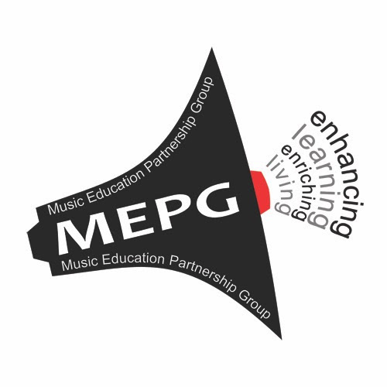

MUSIC EDUCATION PARTNERSHIP GROUP
enriching living and enhancing learning through music education

STRATEGY 2022-26

To realise music’s potential to transform life chances

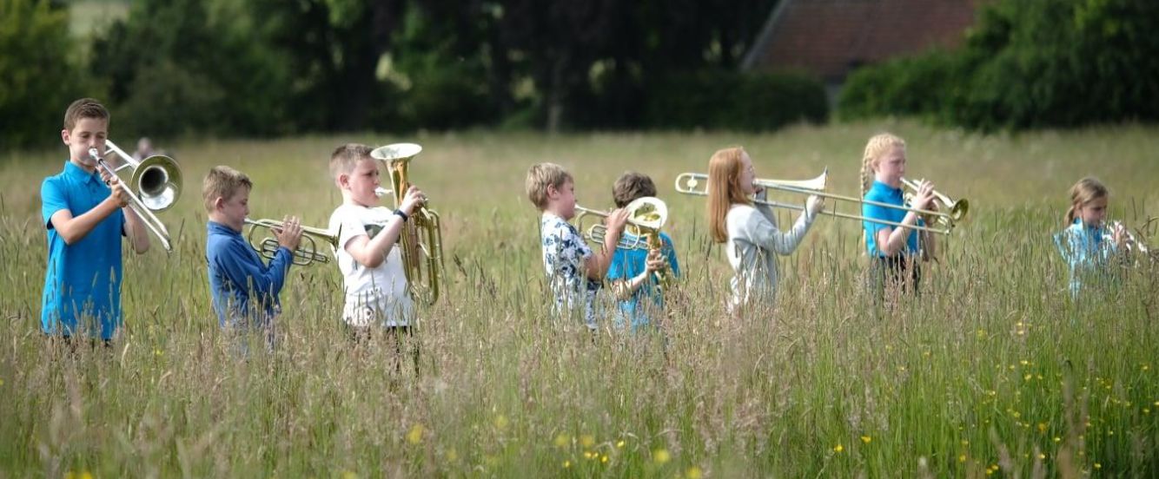

Everyone has the right to participate freely in musical life

Our Vision
Scotland as a place where the transformative potential of music is valued, nurtured, and experienced by all

Our Mission

To realise music’s potential to transform life chances

Our Aims

- To promote equity of access to music provision

- To foster quality learning experiences

- To improve perceptions of the value of music
education

What the Music Education Partnership Group will do:

Aim 1: Equity of access to music provision
- Begin research to understand and explain the many barriers to participation
- Produce a comprehensive infographic map giving a picture of music education in Scotland today
- Continue to work with the Scottish Government and local authorities as universal free instrumental music tuition is rolled out
- Build a Youth Forum
- Complete and publish research into teacher confidence in teaching music in primary schools

Aim 2: Quality learning experiences
- Set up and run the first We Make Music (WMM) school pilots in Renfrewshire and Perth and Kinross
- Co-ordinate with partners to set up WMM instrument libraries in Edinburgh City, Fife, and North Ayrshire

Aim 3: The value of music education
- Set up a Scottish Young Musicians Festival celebrating the personal achievement of young music makers across every local authority in Scotland
- Participate in the Cross-Party Group for Music and contribute towards cross-party support for music education in Parliament
- Work with the General Teaching Council for Scotland on registration for instrumental music instructors
- Advocate for a broadening of the diversity of teaching staff
- Hold 'Sing & Play to Learn' national events at the Glasgow Royal Concert Hall

- Establish a dialogue with the proposed National Centre for Music

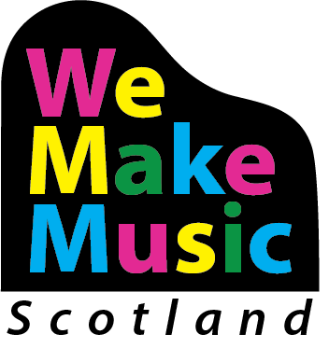

We Make Music
We Make Music is a fresh approach to music education which will help ensure that Scotland is a place where music is valued, celebrated, and nurtured; where music is woven through everyday life, shaping, and being shaped by society, its transformative potential experienced by everyone. Music is the source of a rich musical heritage and creativity. It is inspired by people and place, enlivens every community, and is celebrated around the world.

We Make Music will be designed to build on the success of existing music education and run in parallel with the Youth Music Initiative which has become an important part of year-on-year delivery to children and young people.

- We Make Music (WMM) will be all genre, and Scotland-wide.
- A WMM kite-mark will be developed to celebrate good practice in music education in Scotland across the formal and non-formal sectors
- We Make Music will be supported by digital resources and a knowledge base accessible on tablets and mobile devices as part of a blended learning approach
- We will reach out to the MEPG Youth Forum, the National Parents Forum, and those children and young people involved in the Music Leaders programme to develop WMM.
- WMM will build, develop, and support a stronger, more diverse and flexible workforce from different backgrounds. The workforce will have the skills to meet the needs of the wide range of learners enabling them to achieve their potential with pathways to further and higher learning
- Integral to WMM will be a mentoring system for tutors at all stages

You can read the full MEPG strategy at wemakemusicscotland.org

Registered SCIO – SC050352

