

Add your logo here

**Keep social distance**

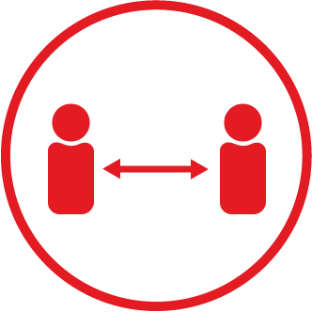

**Stop the spread of Covid-19**