

Add your logo here

**Wash hands**

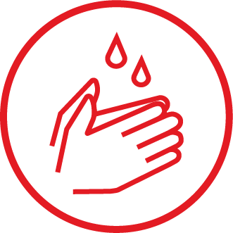

**Stop the spread of Covid-19**